A cell must be complete at the end of every pass.
It may be “original” or “modified.”
It may be “active” or “reference.”
If it is modified, it may not be active.
Complete means that
- it has no “reference” faces or T edges.
- It is closed (every edge has exactly two faces which must belong to this cell.)

Step 1
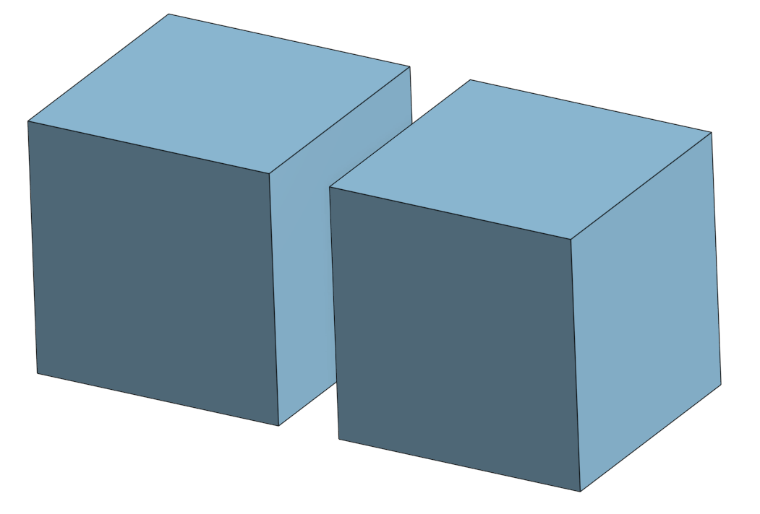
Figure 1
Two cells, unsplit

Step 2
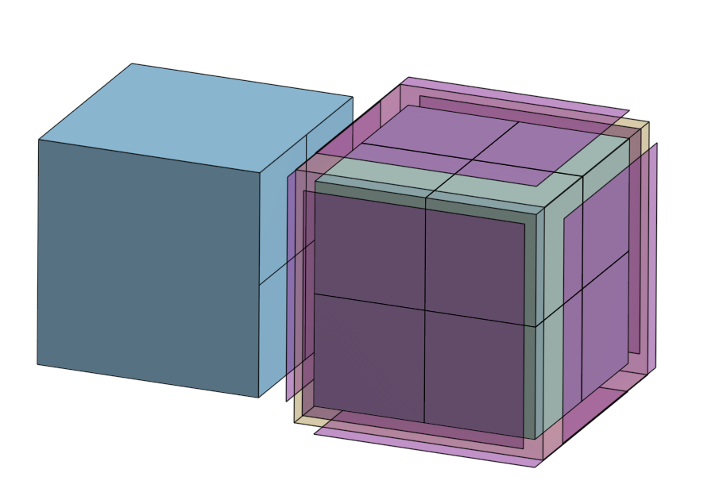
Figure 2
Right cell is fully split
Original cell is now reference. It owns its faces which are reference.
The 8 new subcells and faces are unsplit, intact, reference their originators and their reference originators reference them in return.

The original, reference cell is topologically and geometrically unchanged – but is recorded as reference only. It’s contents no longer affect the output, but are available for reference.

Left, neighbor cell, is NOT YET referenced but uses one of the unsplit reference faces.

This is an incomplete and invalid state.

Step 3

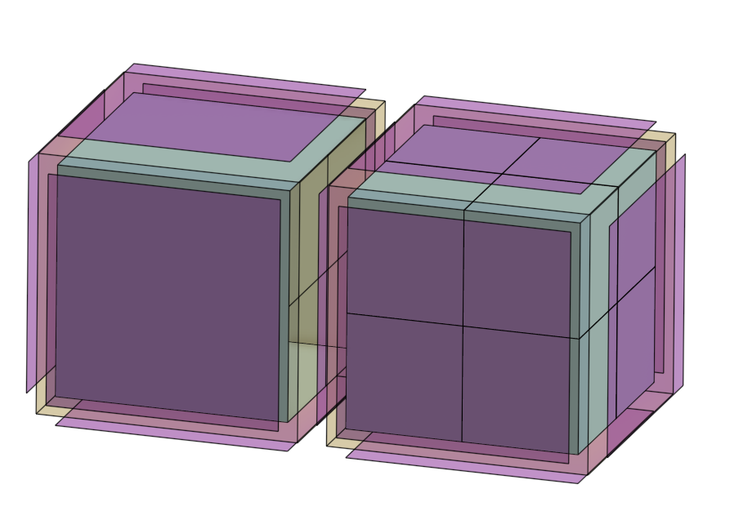
Figure 3

Make left, unsplit cell with 1 or more split faces reference.
Create a new cell with NON reference faces

The original cell now has identical topology and geometry, has no effect on the output and is reference only.

Step 4

Imprint T joint vertices into neighbor edges in the duplicated cell. Not illustrated.

The model is now in a valid state
Second, partial split, first pass
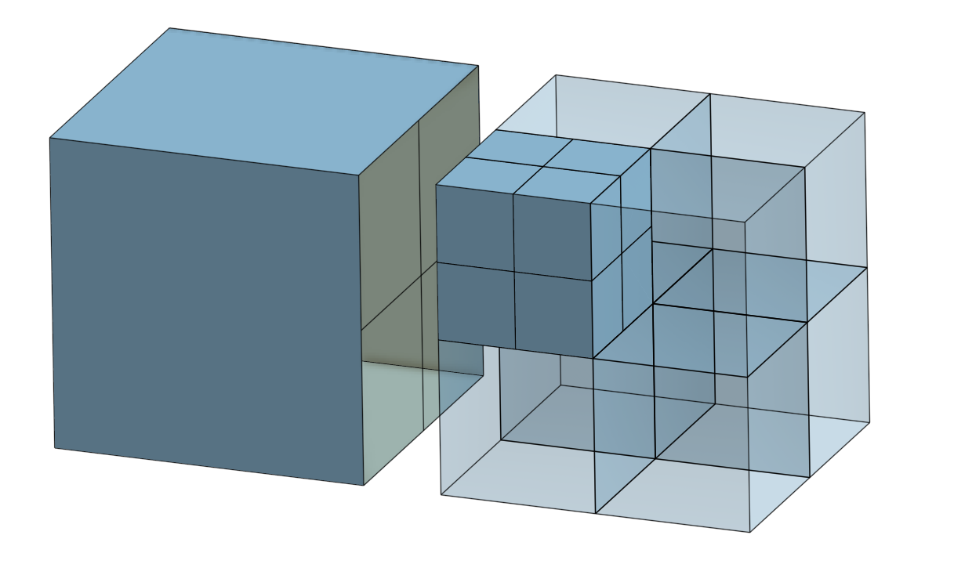
Figure 4

The left-upper, product cell of the original right cell, which is adjacent to an unsplit cell with a shared, split face; must now be split.

If the adjacent unsplit cell is NOT split, this would produce a legal, but undesirable cell with 7 subfaces on a reference face. It’s undesirable because it will be difficult to split later and should be split now.

The adjacent cell must be split before splitting the small, split cell.

How is this condition detected?

The face of adjacent cell to be split is not directly owned by its cell? No

The face of adjacent cell to be split has 1+ adjacent faces with split edges? Maybe…, test this. This looks right.

Mark cells needing split. Don’t use stage marks. Let the cell/face state determine when to split.
Stage 0 are cells which must be split to avoid the problem described in figure 4.
Stage 1 is the usual splitting process.

- Mark splits
- Do phase 0 splits. These require using the reference entities and create original ones
  - Do phase 0 face splits. This splits the unsplit faces of partially split cells.
  - Do phase 0 cell splits. This puts all faces and cells to be split at the same “split level.”
- Do phase 1 splits
  - Split faces
  - Split cells
- Promote reference faces to primary – may require making new references
- Imprint T vertices on edges.
  - The cell and its faces cannot be original at this stage. Assure this

Approach 2

Begin with these cells which we want to split this way.

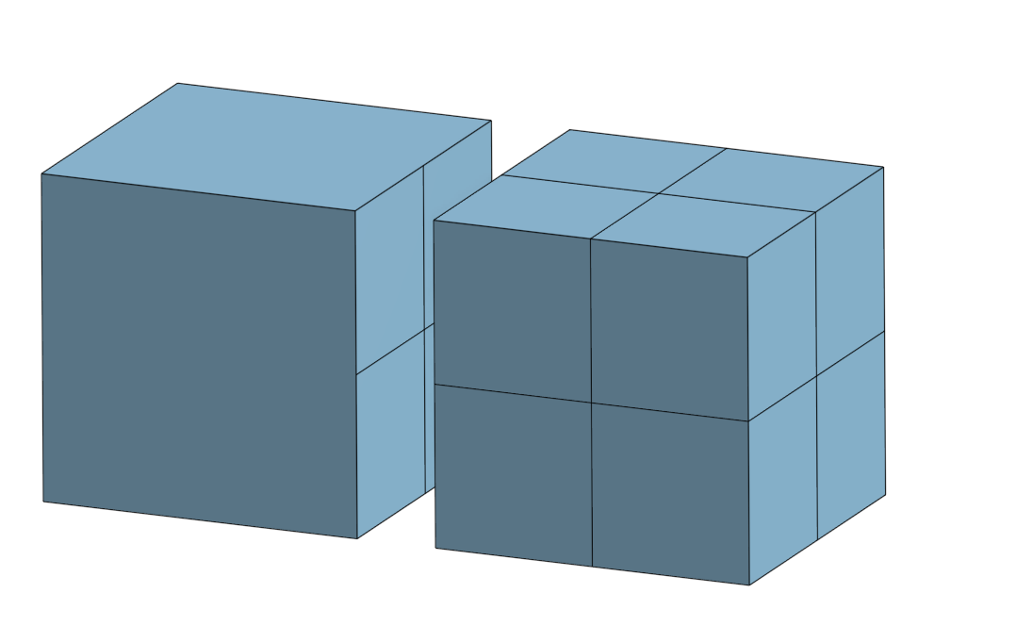

Create reference cells and faces for cells to be modified

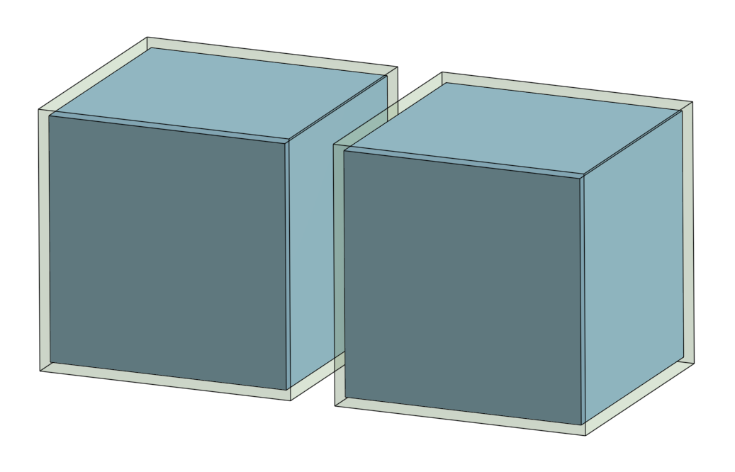

Now split all the faces on the duplicated cells
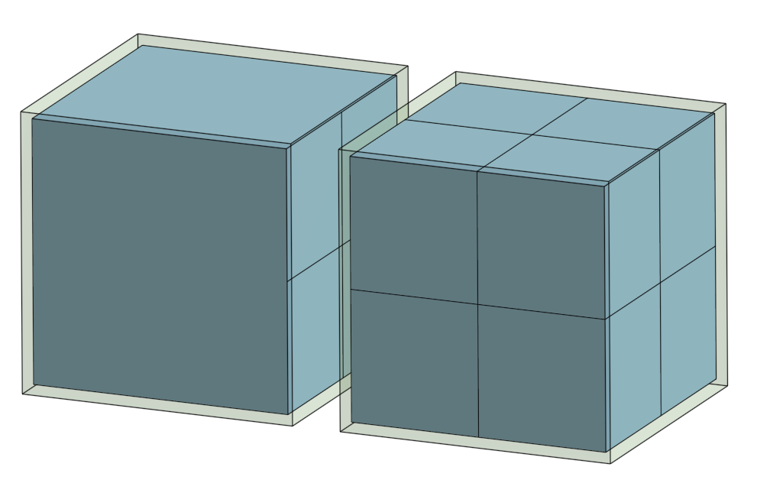

Now split the cells which need splitting

